.

**CITIZEN PERCEPTION SURVEY REPORT**

**INSIGHTS ON GOVERNMENT POLICIES AND PERFORMANCE IN NIGER STATE**



**December, 2024**

Contents

**1.0 INTRODUCTION** 3

**2.0 METHODOLOGY** 3

**2.1 Data Analysis** 3

**Quantitative Data Analysis:** 3

**Qualitative Data Analysis:** 3

**3.0 DATA VISUALIZATION AND INSIGHTS** 4

**Gender Distribution** 4

**Age Distribution** 5

**Marital Status Distribution** 5

**Educational Qualifications** 6

**Occupational Distribution of Survey Respondents:** 7

**Resident Area Distribution** 7

**Distribution of Responses Across Local Government Areas (LGAs):** 8

**4.0 PERFORMANCE RATING ANALYSIS** 8

**4.1 SECTOR-SPECIFIC RATINGS** 9

**4.2 INFRASTRUCTURE RATINGS** 10

**4.3 ADDITIONAL INSIGHTS SUMMARY** 11

**5.0 Conclusion and Recommendation** 11

# **1.0 INTRODUCTION**

This report presents the results of the Citizen Perception Survey on Government policies, programmes, and projects across the 25 Local Government Areas (LGAs) in Niger State, Nigeria. The survey aimed to collect data on public opinions regarding government performance, sector-specific challenges, infrastructure quality, and key policy issues, providing actionable insights into citizen perspectives.

# **2.0 METHODOLOGY**

### Thirty-four thousand four hundred and thirteen (34,413) questionnaires were administered to respondents across the 25 LGAs of Niger State. Two hundred and fifty (250) enumerators were recruited to conduct one-on-one interviews with the respondents. The collected data was then analyzed using various statistical methods.

### **2.1 Data Analysis**

The collected data was analyzed using a combination of descriptive and inferential statistical techniques for quantitative data and thematic analysis for qualitative data.

## **Quantitative Data Analysis:**

**Tools**: Data was processed using Excel and Tableau for visualization and summary statistics.

**Descriptive Statistics**: Frequencies, percentages, and averages were used to summarize citizen responses to various questions.

**Inferential Statistics**: Correlation and regression analyses were employed to identify relationships between demographic variables and perceptions of government performance.

## **Qualitative Data Analysis:**

**Thematic Analysis**: Open-ended responses were coded and categorized into recurring themes to identify key concerns and priorities expressed by citizens.

**Sentiment Analysis**: Textual responses were analyzed to gauge the overall sentiment of citizens toward government initiatives.

### **The report is structured into the following key Analysis:**

1. **Descriptive Analysis**

Demographic Breakdown: Analyze gender, age, marital status, educational qualifications, and occupations to understand the respondent population.

Local Government Area (LGA) Representation: Assess the distribution of responses across the 25 LGAs.

1. **Performance Rating Analysis**

Overall Government Performance: Examine the distribution of ratings on government performance.

Sector-Specific Ratings: Evaluate ratings on challenges like unemployment, poverty, insecurity, healthcare, and education quality.

Infrastructure Ratings: Assess the quality ratings for roads, water supply, electricity, and healthcare facilities.

1. **Sentiment Analysis**

Opinions on Government Policies: Analyze open-ended responses on the most impactful policies and pressing issues to identify recurring themes.

Suggestions for Improvement: Use text analysis on suggestions for improving government performance.

# **3.0 DATA VISUALIZATION AND INSIGHTS**

This section presents visual representations of the survey data, aimed at enhancing the understanding of citizens' opinions on government policies and performance. The visualizations provided in this section offer a detailed look at demographic trends, performance ratings, and public sentiment, revealing key areas for policy and performance improvement.

### **Gender Distribution**

From the questionnaires retrieved, 66% of respondents were male, while 34% were female. This distribution indicates a male-dominated response pattern in the survey, which could imply a higher male engagement or representation in the survey process.

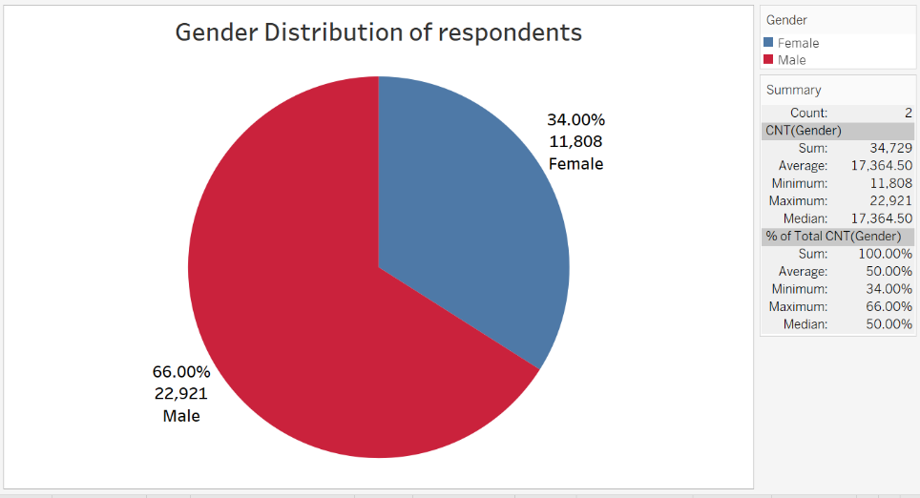

Figure Fi Figure 1.1 Gender Distribution of Survey Respondents

### **Age Distribution**

A significant portion of respondents, 39.39%, fell within the 26–35 age group, making it the largest demographic in the survey. The next most common age bracket was 36–45 years, accounting for 26.54% of participants. Respondents aged 18–25 constituted 21.43% of the survey, while those aged 46–55 made up 9.57%. Individuals aged 55 and above represented a mere 3.08%. This age distribution underscores the dominant presence of younger individuals, with 78.92% of respondents being between 18 and 45 years old.

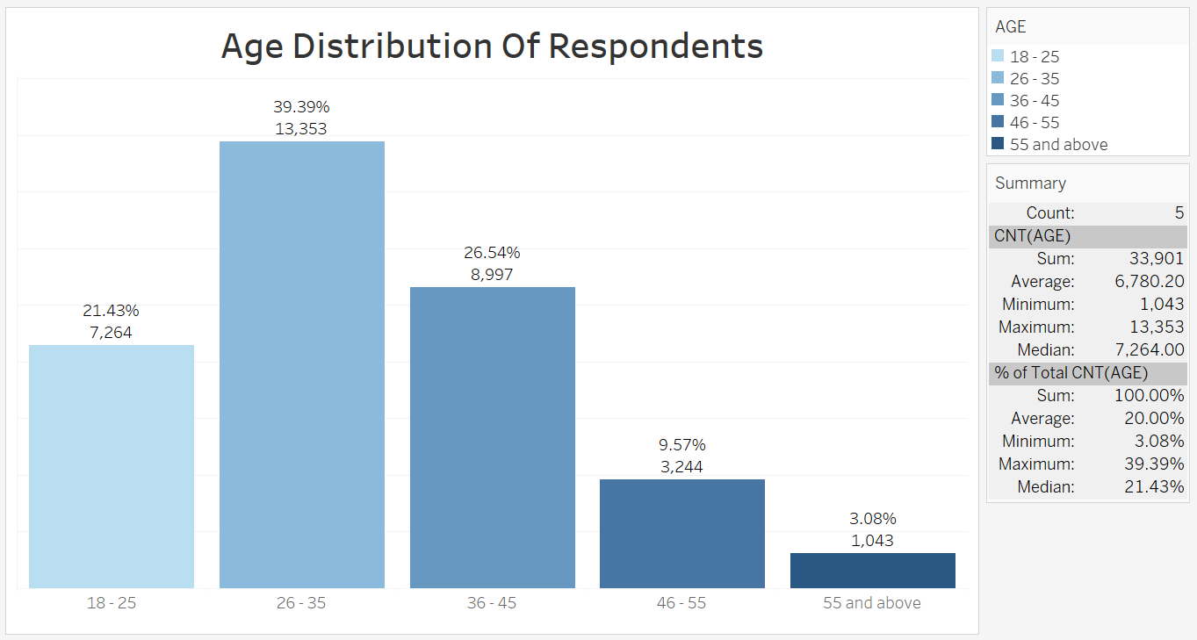

Figure . Age Distribution of Survey Respondents

### **Marital Status Distribution**

The majority of respondents, 60.10%, were married. Single individuals accounted for 31.64% of the participants. Those who were divorced made up 5.62%, while 2.64% of respondents were widowed.

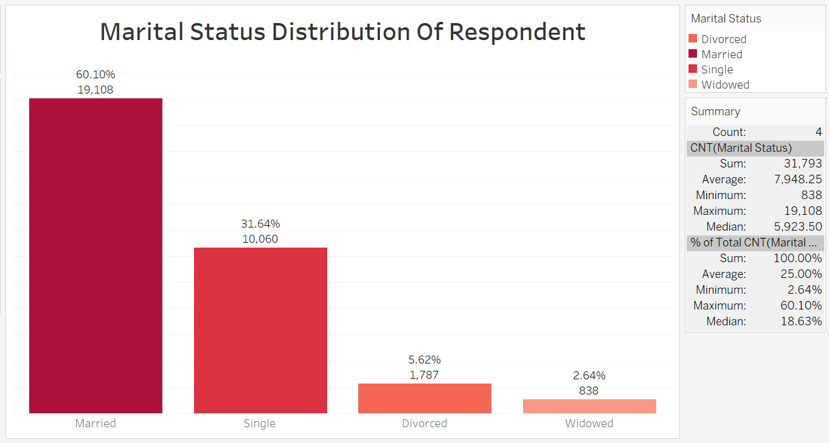

Figure : Marital Status of Survey Respondents

### **Educational Qualifications**

A substantial 41.62% of respondents have completed secondary school, while 24.79% have attained tertiary education. Additionally, 18.10% of respondents reported having no formal education, and 15.49% have completed primary education.

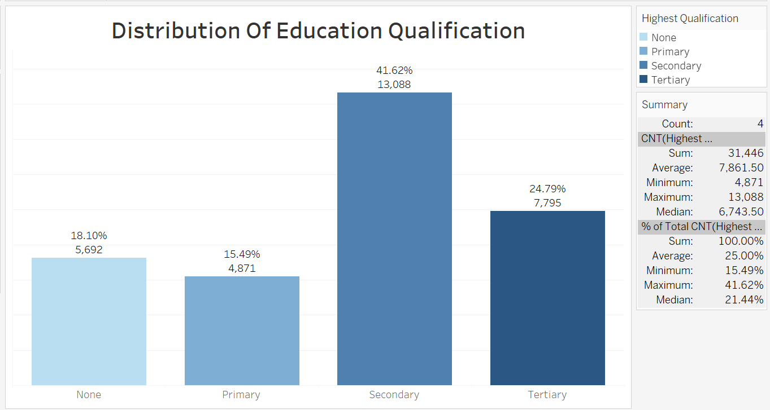

Figure : Educational Qualifications of Survey Respondents

### **Occupational Distribution of Survey Respondents:**

The data indicates that 10.54% of respondents are civil servants. Meanwhile, 16.98% fall into the "Others" category, 17.39% are unemployed, 23.37% are students, and the largest group, 31.72%, comprises business owners.

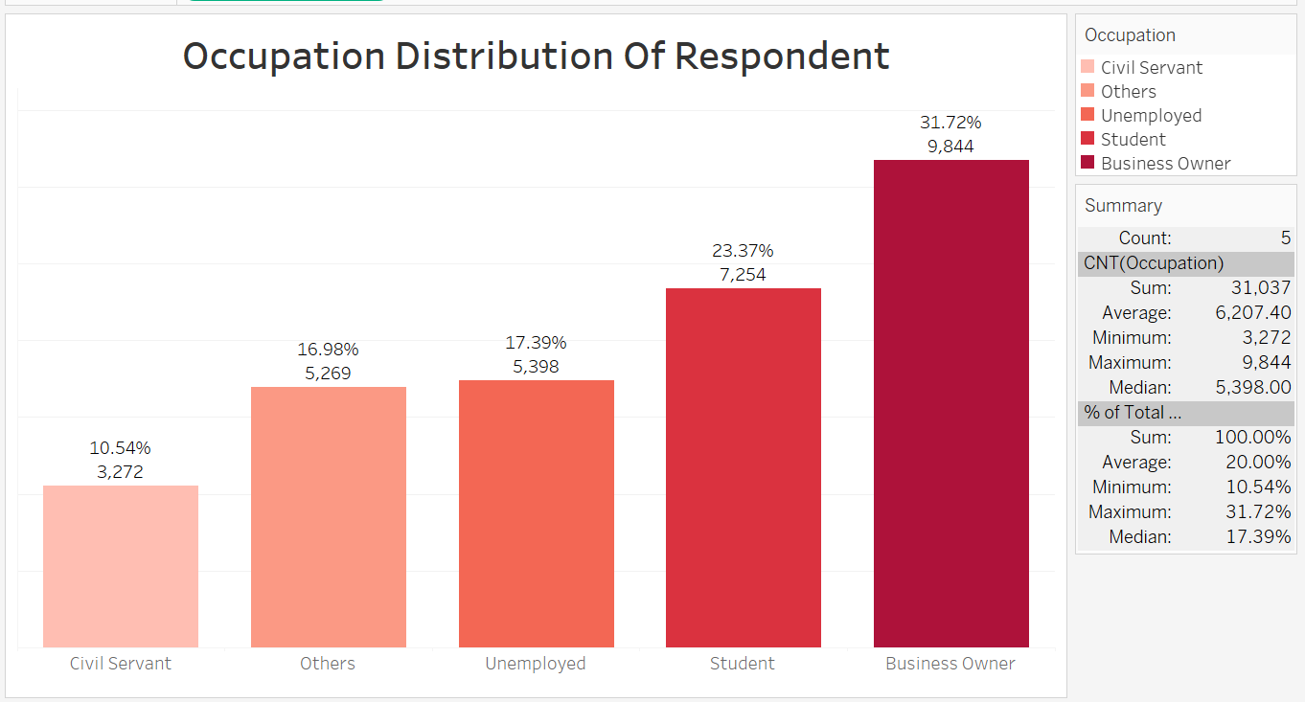

Figure : Occupational Distribution of Survey Respondents

### **Resident Area Distribution**

A significant 81.90% of respondents reside in rural areas, while 18.10% live in urban areas.

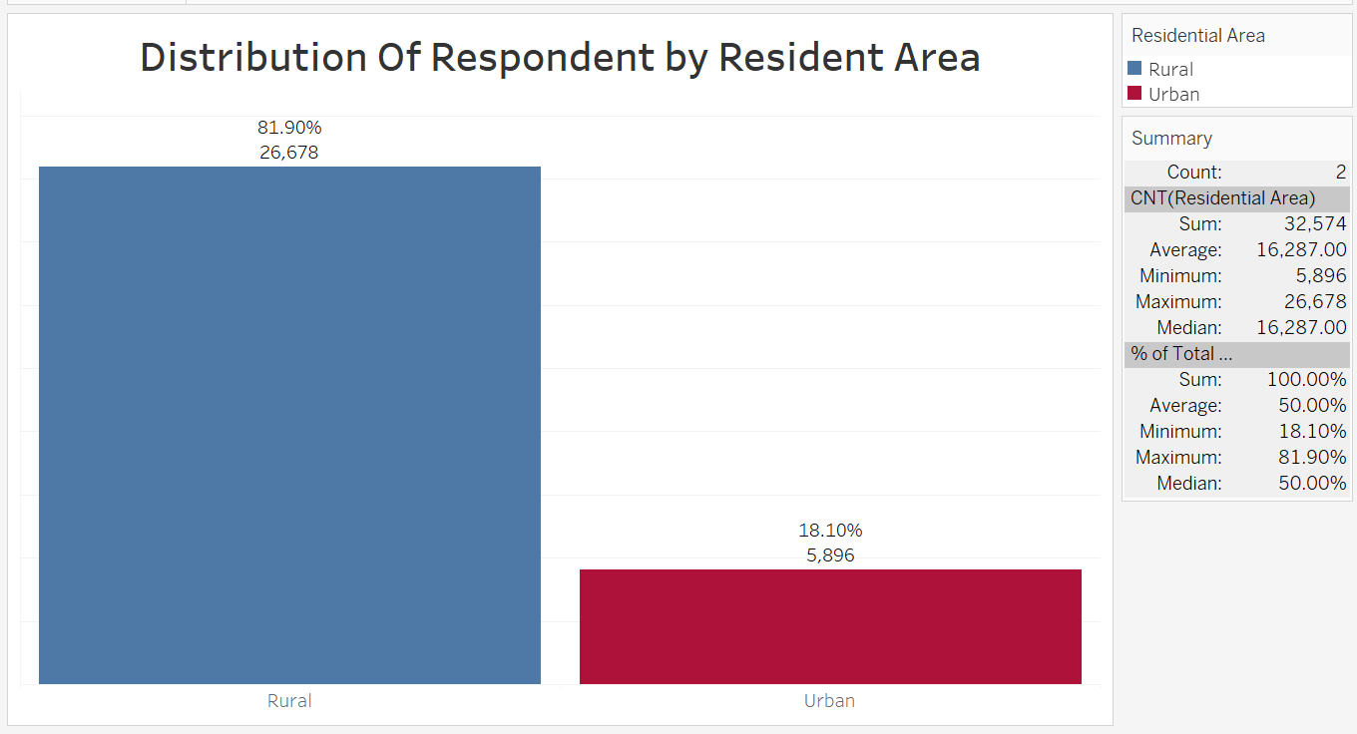

Figure : Resident Area Distribution of Survey Respondents

### **Distribution of Responses Across Local Government Areas (LGAs):**

Suleja had the highest participation, with 7.09% (2,470 respondents), reflecting its higher population density and potential urban engagement. Gbako followed closely, contributing 6.12% (2,133 respondents) of the total survey responses. Edati, Mokwa, Lapai, and Katcha collectively accounted for significant shares, ranging from 5.92% to 5.18%. Rural LGAs such as Rafi and Rijau had minimal representation, with only 0.57% (200 respondents) and 0.35% (121 respondents), respectively. Participation in other LGAs like Borgu, Lavun, and Magama ranged between 5.00% and 4.17%, showcasing a mix of moderate engagement.

# **4.0 PERFORMANCE RATING ANALYSIS**

The chart below illustrates the distribution of citizens' ratings on overall government performance. The data reveals that the largest group of respondents, 38.08%, rated the government’s performance as "Good." This was followed by 24.77% who rated it as "Excellent." Meanwhile, 22.18% rated the performance as "Fair," reflecting a neutral perspective. On the other hand, 9.49% expressed dissatisfaction by rating the performance as "Poor," and 5.49% rated it as "Very Poor." This indicates that while there is a significant amount of positive perception, a portion of the population remains either dissatisfied or neutral.

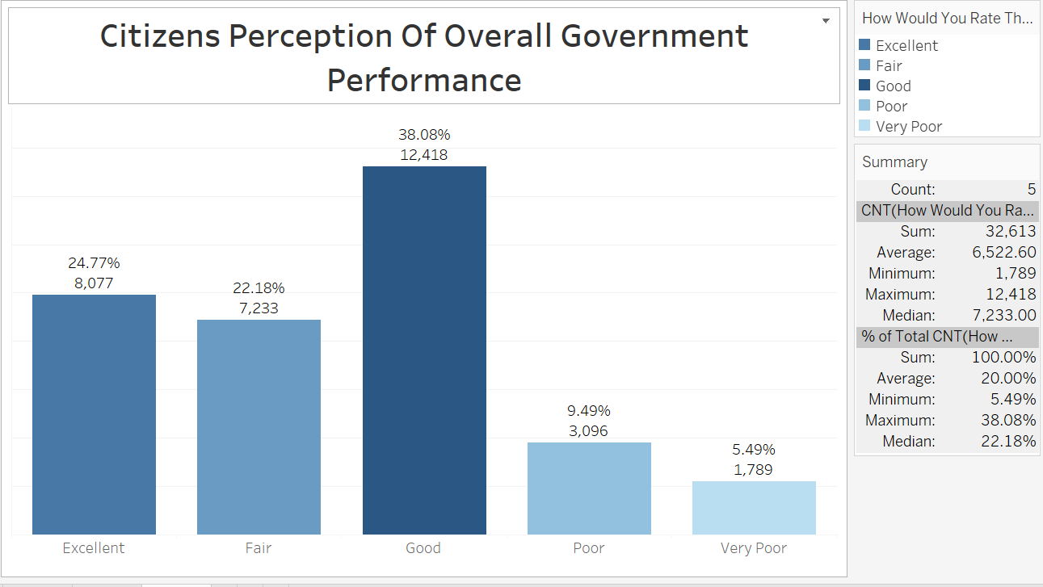

Figure 7: Citizens Perception of Overall Government Performance

## **4.1 SECTOR-SPECIFIC RATINGS**

The sector-specific ratings from the survey highlight citizens' diverse opinions on various governmental efforts. In education, 14.42% rated quality as Effective, while 37.32% deemed it Not Effective. Healthcare services saw 15.89% rating them as Effective, with 31.17% considering them Not Effective. For poverty alleviation, 12.15% found the efforts Effective, and 40.30% considered them Not Effective. Security and safety measures were rated Effective by 15.00% of respondents, but 36.82% viewed them as Not Effective. Lastly, 10.31% found government measures addressing unemployment Effective, whereas 52.57% rated them as Not Effective. These findings underscore varied perceptions, with notable portions of the population expressing dissatisfaction or uncertainty across all sectors.

## **4.2 INFRASTRUCTURE RATINGS**

The survey highlights citizens' diverse opinions on various infrastructures. Only 12.93% found education infrastructure effective, while 34.77% deemed it ineffective. Similarly, electricity infrastructure was rated effective by 11.88% of respondents, with 35.23% considering it ineffective. Healthcare infrastructure saw 14.43% rating it as effective, but 30.11% viewed it as ineffective. Road infrastructure had a mere 12.30% effectiveness rating, with 43.47% seeing it as ineffective. Lastly, water infrastructure was rated effective by 12.10%, while 34.14% found it ineffective. These findings suggest significant room for improvement across all infrastructure sectors.

## **4.3 ADDITIONAL INSIGHTS SUMMARY**

The survey provides valuable insights into citizens' perceptions of various government initiatives and expenditures. Education reform is viewed positively by 30.83% of respondents who rated it as Good, followed by 30.10% who rated it as Fair. However, 20.50% rated it as Poor, highlighting areas needing improvement. Regarding government spending in healthcare, education, and infrastructure, 27.07% rated it as Effective, while 28.49% were Neutral, and 19.13% found it Not Effective. This mixed perception suggests varied opinions on the efficiency of government spending. When rating government policies and programs, the Healthcare Initiative received the highest approval at 30.82%, followed by Infrastructure Development at 20.50%, and Education Reforms at 18.90%. The least approved policy was Security Measure, with only 5.12% endorsement. These insights emphasize the need for continued evaluation and enhancement of government initiatives to better meet citizens' expectations.

# **5.0 Conclusion and Recommendation**

The Citizen Perception Survey in Niger State offers valuable insights into public opinions on government policies, programs, and infrastructure across the 25 LGAs. While there are areas of success, several sectors indicate the need for significant improvements. To address these concerns and enhance public satisfaction, we recommend the following actions:

**1. Enhance Education and Infrastructure:** The survey revealed that only 12.93% of respondents found education infrastructure effective. To improve this, the government should prioritize investment in modernizing educational facilities and training for educators to better meet the needs of students. Similarly, the low effectiveness ratings for road (12.30%) and water infrastructure (12.10%) call for urgent upgrades and maintenance to ensure accessibility and quality for all citizens.

**2. Improve Healthcare Services:** While 30.82% of respondents approve of the Healthcare Initiative, the effectiveness rating for healthcare infrastructure was just 14.43%. Strengthening healthcare services through increased funding, better equipment, and more trained healthcare professionals can significantly enhance public health outcomes.

**3. Increase Transparency in Government Spending:** With mixed perceptions on government spending in healthcare, education, and infrastructure, it is crucial to enhance transparency and accountability. Implementing a clear and accessible reporting system on how funds are allocated and spent will help build trust and demonstrate the government's commitment to efficient use of resources.

**4. Address Unemployment and Economic Empowerment:** The effectiveness of government measures in addressing unemployment is rated low at 10.31%. Creating more job opportunities, supporting small businesses, and implementing targeted economic empowerment programs can help reduce unemployment and foster economic growth.

**5. Strengthen Security Measures:** Only 15% of respondents rated security measures as effective, with 36.82% considering them not effective. Improving security infrastructure, increasing the presence of law enforcement, and engaging community policing strategies can enhance citizens' sense of safety and security.

**6. Foster Continuous Engagement with Citizens:** To ensure that government initiatives align with public expectations, continuous engagement and communication with citizens are essential. Regular feedback mechanisms, such as town hall meetings and online surveys, can provide ongoing insights into citizen needs and concerns.

By addressing these key areas, the government can make significant strides in improving the quality of life for all citizens in Niger State. These actions will not only enhance public satisfaction but also build a stronger, more resilient community.